Lecture 09

Run-Levels continue

---------------------------

Run levels

$ init 3 --> to go to runlevel 3 which is CLI

*here the logic is,

All the runlevels are available as VCs (Virtual Consoles) these VC can be used but 6 users simultaneously at runlevel 2, 3, 4. But changing runlevel will close VCS at previous runlevel and open ne VCs for new run level.

* The VC at runlevels is called “GNOME Termilans”
* The GUI in runlevel 5 is called Gnome Desktop
* In runlevel 5 400 terminals can e opened and used at once. Where r at runlevel 3 6 terminals can be utilized.
* Here we can switch any runlevel with ALT+(F1..F7) , the system swaps the required level and put the pervious behind.
* To check run “ps” command
* 
* Here tty2 indicates that we are on runlevel “2”
  + “tty” is a driver which works behind these consoles
  + /dev/tty1
  + /dev/tty2
  + /dev/tty3
  + /dev/tty4
  + /dev/tty5
  + /dev/tty6
* From VCS Genome Terminal can be loaded.
* In case at runlevel 5 GUI Gnome Terminal is not opening , 6 VCS can also be loaded by bydefault Gnome Terminal is associated with runlevel 5. (these default settings can be changed/modified)
* It is important to note that when ne VC is swaped by AL+ combination it shows the previous tty driver which switched to present VC as shown in following snippets, 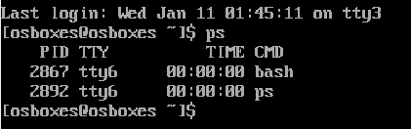

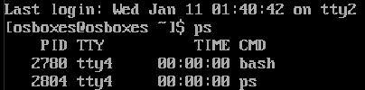

*tty means terminal

$ ls -l /dev/tty 🡪 to look at tty’s available

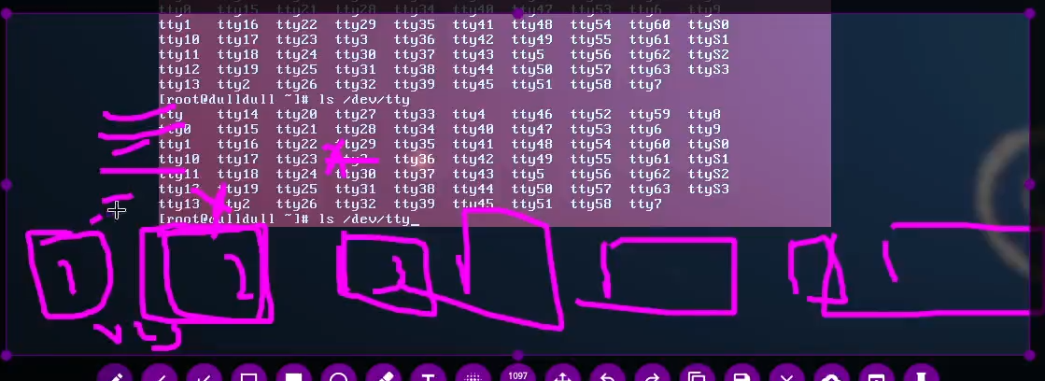

*if related “tty” drives is removed, it is quite possible the related consol will also not open or appear.

**REMEMBER :-** the 6 terminals in runlevel 3 are Virtual Consoles associated to runlevel3 and at runleval5 the Gnome Terminal and GUI are a separate things. These 6 VCS should not be confused with runlevels which are 7 and can be switched by “init” command.

* The driver behind Gnome terminal is called “pts”. It stands for Pseudo Terminal
* To look at it
* $ ls command is used
* $ ls /dev/pts/0 🡪 every terminal will keep on increasing the digit after pts … pts0, pts1,pts2,pts3…. Pts400 (approx.)
* pts is used for remote connection also. Where as “tty”is used for physical connection.
* #In windows “PuTTY” is used for remote sessions (terminals) of Linux machine. The fact is “pts” belongs of Gnome Terminal which is GUI in Linux but PuTTY will have no GUI access.
* 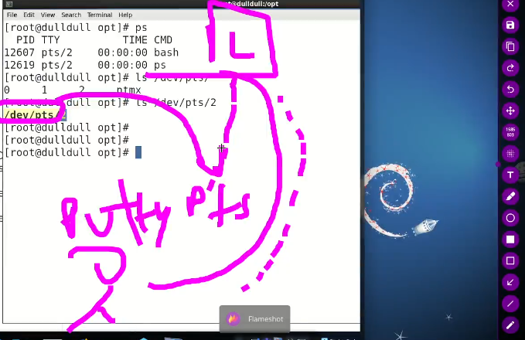
* Now, the process of switching to runlevel 3 stops certain services and starts certain services for runlevel 3 and whenever we switch back to runlevel 5 same thing happens and some services are stopped and some services are started , to avoid this and to have temporary GUI access at runlevel 5 we use this method, remember its will show runlevel 3 if checked
* $ runlevel
* 5 3
* **$ startx 🡪** it temporary loads the graphics without switching runlevel
* **$ pkill x 🡪 this command will terminate the temporary GUI session and resumes runlevel 3**
* *the GUI is called x server in Linux

Boot process defined

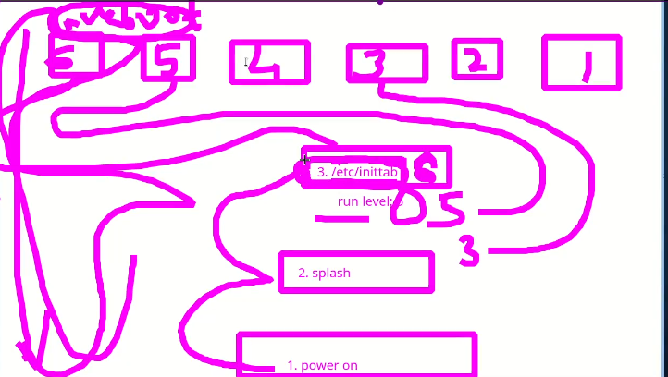

1. Power on
2. Splash screen(can be interrupted by pressing specific keys)
3. /etc/initab 🡪 runlevel : ?
   1. Here further process depends upon run level written in “inittab”file.

I have set the default mode to runlevel 3 after listening Sir. Kazim who emphasized to work in CLI.

The steps are,

* $ cd /etc 🡪 Open etc directory where inittab file is located
* $ ls -l inititan 🡪 check availability of the file
* $ cat inittab 🡪 to read contents of the file
* Screenshot
* 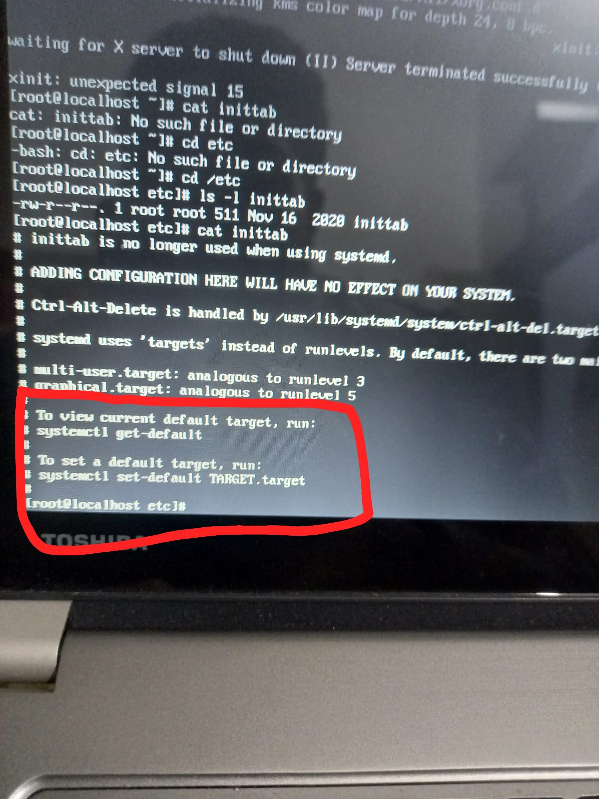

The whole process is given in screenshot

**Note: -**

**$ shutdown -r now 🡪 to shutdown**

**To change root password in CentOS interrupt splash screen and press a to go to init 1 rinlevel 1 and edit,**

**$ password root 🡪 to reset password**

For security reasons it is not a great things to allow everyone to change root password with this trick,

So,

To stop it, follow these steps

On CentOS 6

Open terminal

$ vi etc/sysconfig/init

SHIFT+G to go to end of the file



“sushell”

Press “yy” to copy this line and paste it but comment out first row



**SINGLE is called TAG** and after = everything is called value

Here replace **“sushell”** with **“sulogin”**

Which always require password because sulogin calls the script for single user mode which requires password.

**SITUATION**

If root password is forgotten and runlevel 1 is secured with “sulogin”, then what would be the situation???

The solution is that here at this point we need to rescue the situation, we need DVD/ISO of CentOS 6 to login without password and change the root password.

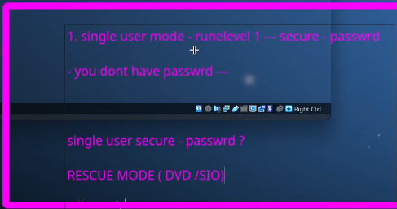

Same situation in CentOS 7 & 8

How to deal with it?

Solution is,

In CentOS7 & 8

There is no key for modifying the boot process

So,

* “e” to edit
* 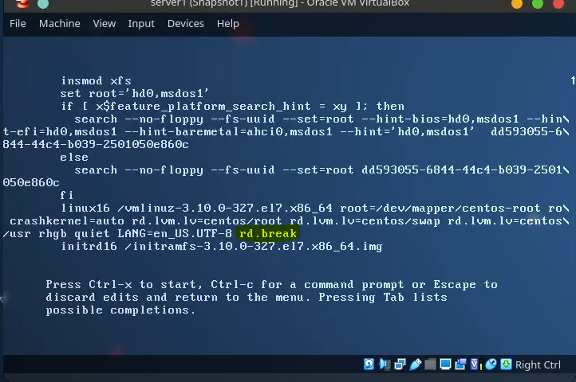

- Type “rd.break” and Ctrl+X to start

- 